5.4 Event Binding



This section will guide you to:

* Implement event binding

This guide has two sections, namely :

5.4.1 Implementing event binding

5.4.2 Pushing the code to Github repositories

**Step 5.4.1:** Implementing event binding

* Call *toggleImage()* when any button is clicked in *Product-list.component.html*.
* Add the following code in *products.component.ts*.

import { Component } from '@angular/core';

import { Product } from '../product';

@Component({

  selector: 'app-products',

  templateUrl: './products.component.html',

  styleUrls: ['./products.component.css']

})

export *class* ProductsComponents {

  pageTitle: *string* = "Product List Page";

  imageWidth:*number* = 80;

  imageMargin:*number* = 10;

  showImage:*boolean* = false;

  buttonValue:*string* ="Show Image";

  products:*Array*<Product>=[

   new Product("https://i.pinimg.com/236x/d9/b9/49/d9b9490af419f70a300d4552d6d737af.jpg","Leaf Rake","GDN-0011","March 19, 2016",19.95,3.5),

   new Product("https://i.pinimg.com/236x/1c/46/9d/1c469d4c102b6aa7f89a8c1b7c7cc797.jpg","Garden Cart","GDN-0023","March 18, 2016",32.99,4.2),

   new Product("https://i.pinimg.com/236x/38/13/43/38134365cf2f9a2e4e21ae3b1c7aa158.jpg","Hammer","TBX-0048","March 21, 2016",8.9,4.8),

   new Product("https://i.pinimg.com/236x/0d/ae/ed/0daeedbf7a3c6e22a35623a695a8c31b.jpg","Saw","TBX-0022","March 15, 2016",11.55,3.7),

   new Product("https://i.pinimg.com/236x/43/e7/82/43e78206fa3c28e1bfc8f92ba349052d.jpg","Video Game Controller","GMG-0042","October 15, 2015",35.95,4.6),

 ]

 toggleImage() {

   this.showImage=!this.showImage?true:false;

   this.buttonValue=this.buttonValue=="Show Image"?"Hide Image":"Show Image";

 }

}

* Add the following code in *Products.component.html.*

<div>

    <h1> Product List Page </h1>

    <table class="table">

        <tr>

            <th><input type="button"  [value]="buttonValue" (click)="toggleImage()"/></th>

            <th>Product</th>

            <th>Code</th>

            <th>Available</th>

            <th>Price</th>

            <th>Rating</th>

        </tr>

        <tr *ngFor="*let* p of products">

            <td>

                <span *ngIf="showImage">

                <img

                    [src]='p.imageUrl'

                    [title]='p.productName'

                    [alt]='p.productName'

                    [style.width.px]='imageWidth'

                    [style.margin.px]='imageMargin'/>

                </span>

            </td>

            <td [style.color]="'#306A9D'" [style.font-weight]="700">

                {{ p.productName }}

            </td>

            <td>{{p.code}}</td>

            <td>{{p.available}}</td>

            <td [style.color]="p.price > 20 ? 'red': 'green'"

            [style.font-size.px]="16"  [style.font-weight]="700">

            {{ p.price}}

            </td>

            <td>{{p.rating}}</td>

        </tr>

    </table>

    <div>

    </div>

**Output:**

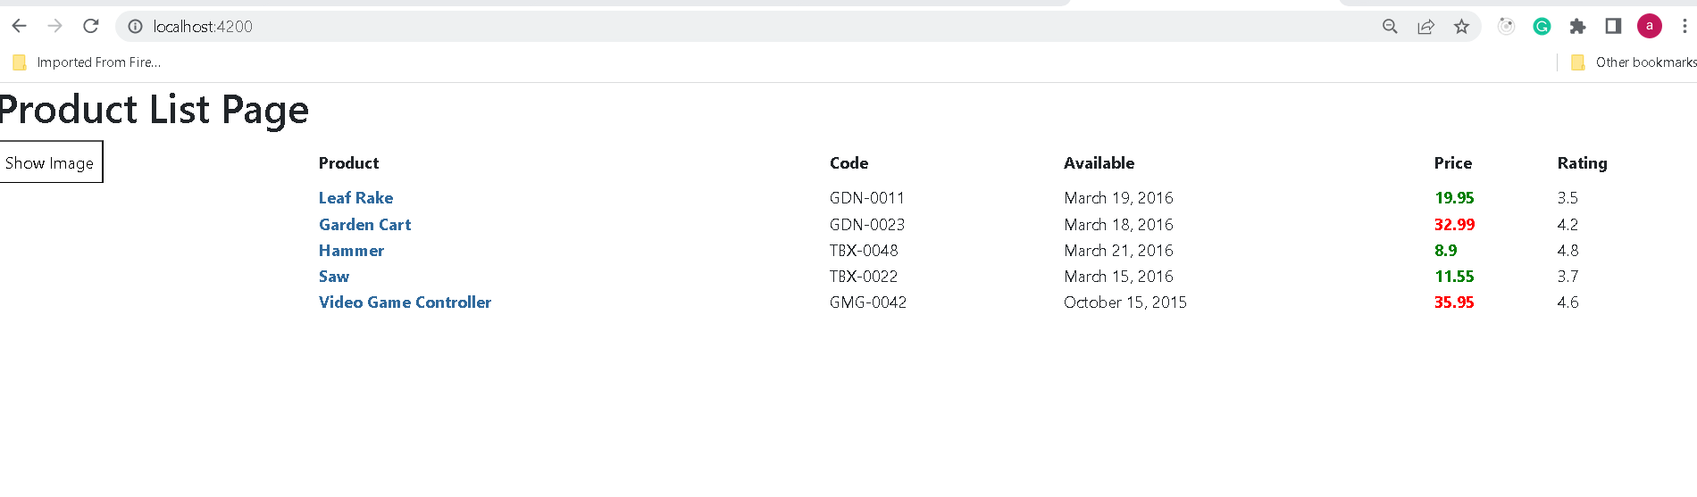

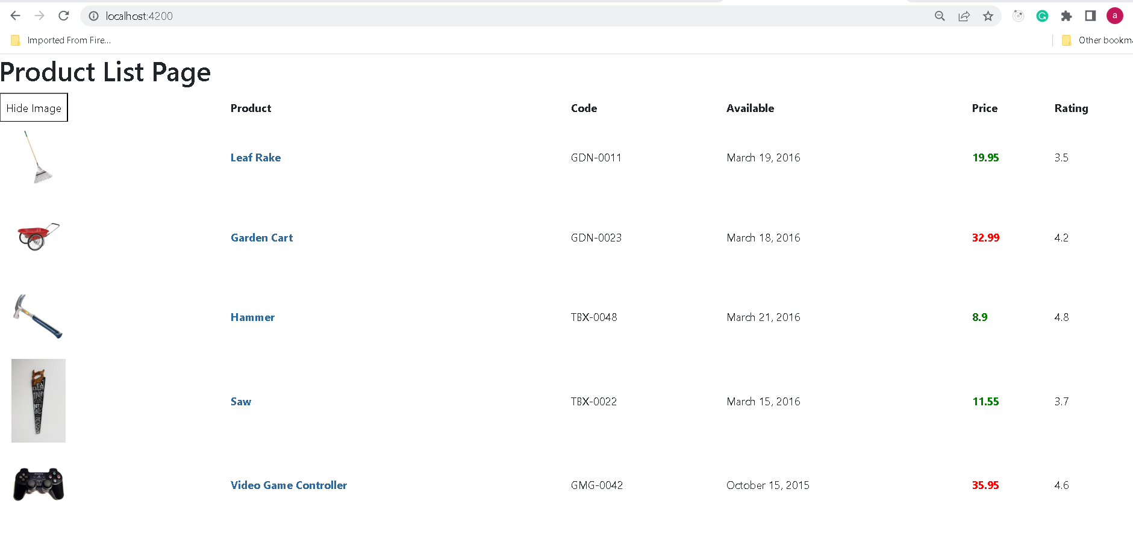

**Step 5.4.2:** Pushing the code to your GitHub repositories

Open your command prompt and navigate to the folder where you have created your files

cd <folder path>

Initialize your repository using the following command:

git init

Add all the files to your git repository using the following command:

git add .

Commit the changes using the following command:

git commit . -m “Changes have been committed.”

Push the files to the folder you initially created using the following command:

git push -u origin master